Document Number | RP2
Document Title | Booking an appointment
Department Ownership | Reception
Document Type | Procedure
Department Owner | Alysia Harper and Angela Di Pardo
Document Author | Alysia Harper and Angela Di Pardo
Last Edited By | Derrick Chan | Lasted Edited On | 07/04/2015

Purpose

The purpose of this procedure is to demonstrate the correct procedure to book an appointment using the Genie Program

Scope

For all staff at Reception

Reference Documents

Definitions

Flowcharts (Other Images)

Procedures

There are a number of ways a company can submit a booking request. Some of those options include calling through or emailing a booking form or request to the health screenings mailbox. NOTE: THE APPOINTMENT TIME GIVEN TO THE CANDIDATE OR THE RECRUITER MUST BE 15 MINUTES PRIOR TO THE ACTUAL SCHEDULED TIME. THIS IS TO ENSURE THE CANDIDATE HAS ENOUGH TIME TO COMPLETE PAPERWORK.

- When taking a call answer the phone professional by introducing the company and yourself. For example “Thank you for calling REDIMED pre-employment, Angela Speaking”. Note: if you are responding to a booking via email simply follow steps 4-24 ensuring you are confirm the details with the patient and the recruiter who has sent through the original email.

- Take note of the name of the person calling you as well as what company they are from.

- Find out what details you need

- What location, date and time they would like the medical to take place?

- What assessments are required?

- Check in Genie and see if we have an appointment available on the desired date and time they have requested. If we can accommodate the appointment let the recruiter know, If we are unable to do so find the closest time or date to that which was requested and try to agree on an appropriate date and time with the recruiter.

- Once they approve the time and date simply ask for the patient’s full name and add in the patient to the appropriate time and date.

- This is done by typing the patients name beginning with the last name into the appropriate slot. (as below) NOTE: IF THE PATIENT ALREADY HAS A FILE IN GENIE A WINDOW WILL APPEEAR (AS BELOW) IF THE PATIENT DOES NOT HAVE AN EXISTING FILE IN GENIE THE NAME WILL APPEAR IN BROWN YOU WILL NEED TO ADD A NEW PATIENT.

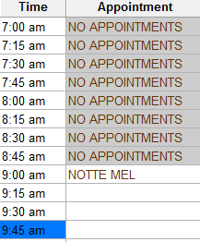

- If the patient has a file in genie confirm details such as date of birth with the recruiter to make sure it’s the correct patient select the correct patient when the window appears. This will then automatically enter the patient into the select slot. (Continue to step 14.)

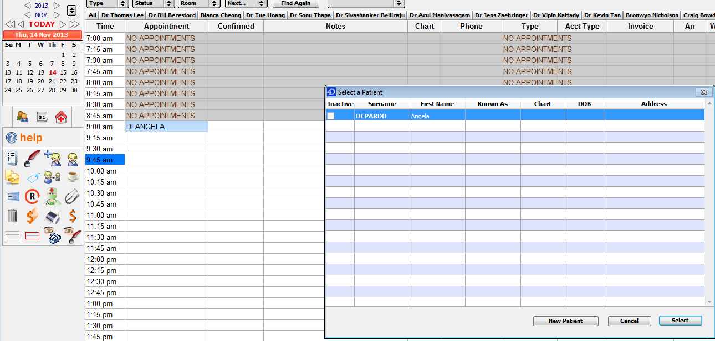

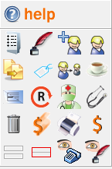
- If the name appears in brown and you need to add a new patient this can be done by selecting the blonde man with the plus sign in the help panel.

- A window will appear this is were you can enter the patients details. Ask the recruiter if they have an address, date of birth and contact number for the canidate and enter what details you have been given. Usually this will include only minimal details such as name, date of birth and contact number this is fine for the time being.

- You also need to add a few extra details for the company. Select the employer tab in the bottom right section. NOTE: ASK THE RECRUITER FOR THEIR EMAIL ADDRESS AND PLACE IT IN THE EMAIL SECTION, THIS IS SO WE HAVE A POINT OF CONTACT.
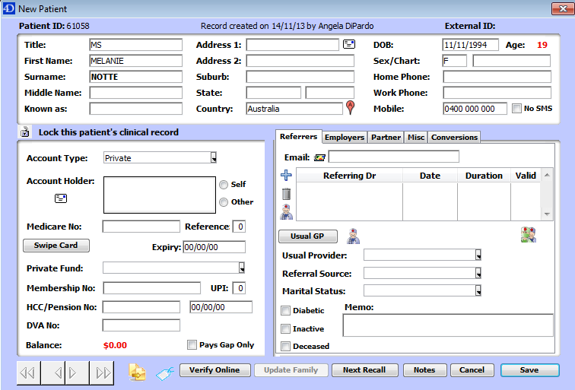

- The window will change slightly so that you can add a new employer (as below).
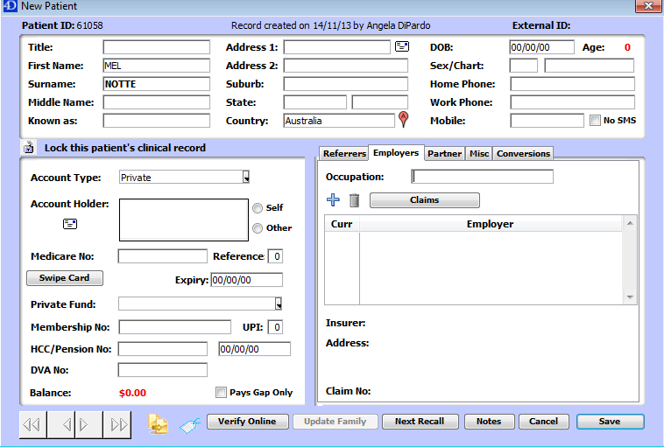

- Select the small plus icon. This will cause a small window to open. Type the company name in the appropriate section.
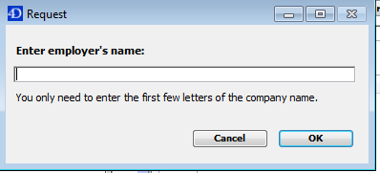

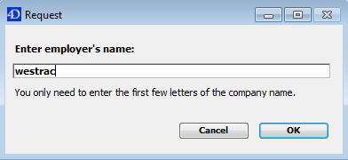

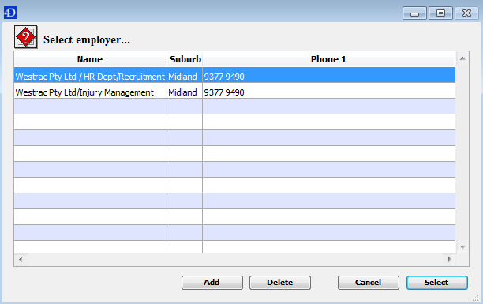
Once you type in a name and select OK a window will appear with all the companies associated with that name. For Pre-employment medicals we must ALWAYS select the company with recruitment (as below). Select the correct option and then select.

- The company will now appear in the original window. And you can save the details.
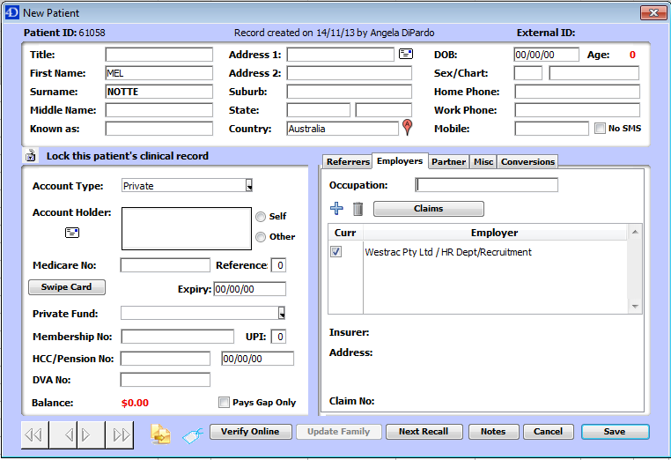

- The patient now has an account and the name will now appear in black.
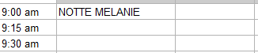

- Confirm with the recruiter what assessments are needed this will determine how many slots the patient will need for the appointment (refer to time schedule).

- To select the time slots left click the patients name with your mouse and drag the cursor down the desired number of slots.
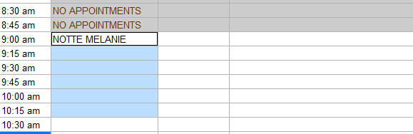

- Once the correct amount of slots have been highlighted group the appointment together by selecting the icon in the help menu.
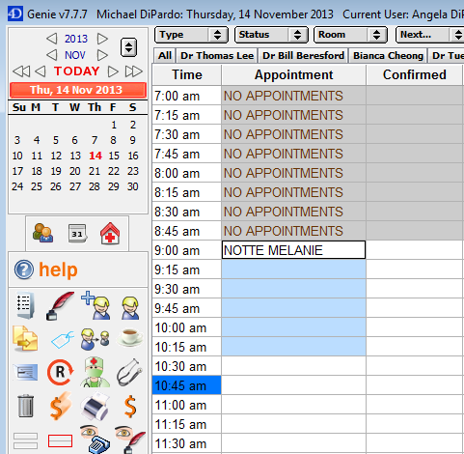

The appointment will then display with a red highlight around it.
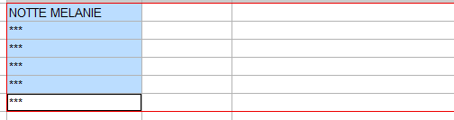

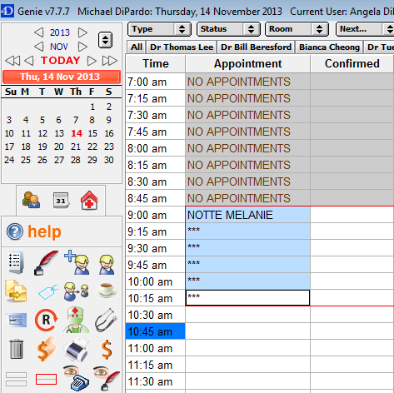
- The appointment now needs to be given a type, this is done by selecting a company from the type menu in the top left corner

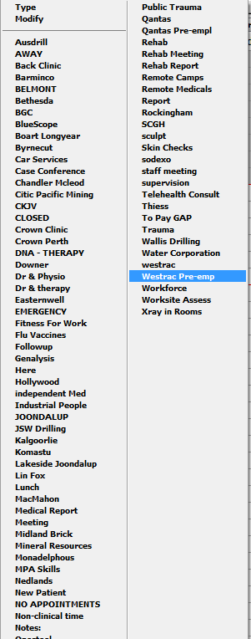
- A drop down menu will appear, select the pre-employment option for the company. NOTE: IF THE COMPANY IS NOT LISTED ON THE MENU SELECT “OTHER”

- Once you have selected the appropriate company it will appear in a colour according to your choice.

- The appointment now has been successfully made under the exercise physiologist.

- Confirm all the details with the recruiter including location, date and time. You may now end the conversation and ask the recruiter to send through a booking form.

- The last step is to schedule a doctor’s appointment to follow if applicable

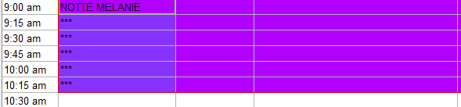

- View the next time slot after the first appointment (in this case it would be 10:30am. In genie toggle over to find a Doctor that is available at 10:30am an add a single appointment (follow the steps above)
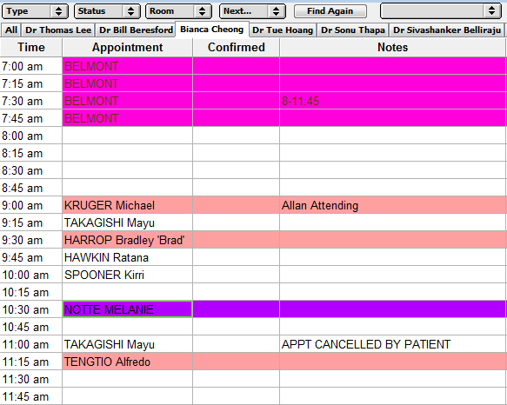

- The appointments now have been scheduled once the booking form is received it can be printed and place in the booking form folder on the appropriate date.

Appendices

